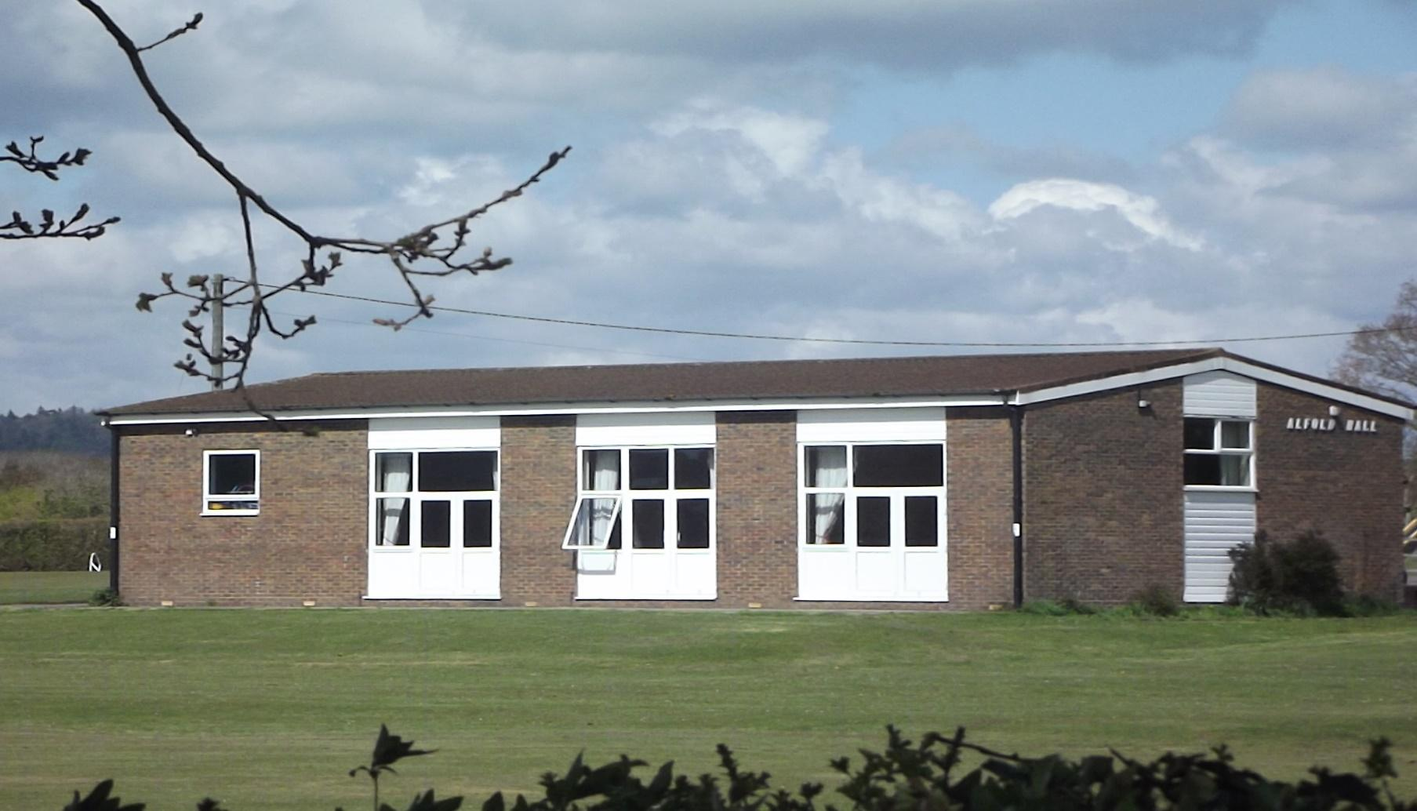
ALFOLD VILLAGE HALL NEEDS YOU!
Alfold Village Hall is a wonderful community asset located at Alfold Crossways. It is used for many different things, from Pilates, Fitsteps, shortmat bowls and dog training to Parish Council meetings, weddings and childrens’ birthday parties.

It has been run for many years by a team of dedicated volunteers, which include a Chairman, Secretary and Treasurer who will now be standing down after a long term (for various reasons) in December 2023.

Without Trustees to take over the duties and overall running of the hall, the hall is in danger of being closed for good. The committee are looking to recruit Trustees (Chairman, Treasurer and Minute Secretary) as well as more volunteers, now, to ensure we don’t lose use of this important community facility. The Trustees would be supported by the team of volunteers and a small staff for the day-to-day maintenance of the Hall.

The duties should not take more than a couple of hours per week per volunteer (at most), including some meetings, fundraising and general maintenance. The positions are very rewarding and fulfilling and provides an integral service to Alfold.

If you are interested, please contact clerk@alfoldparishcouncil.gov.uk or you can have a look at the hall website for further information alfoldhall.co.uk.

